Rotary Club of Seminole County South
P.O. Box 160306
Altamonte Springs, FL 32716-0306
407-494-6748
District 6980 – Club 4418
Membership Proposal Form

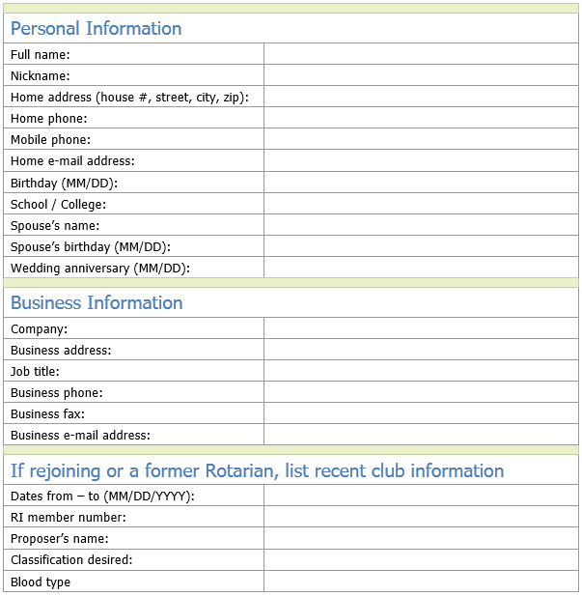
I hereby certify that I am qualified for membership for active membership by my or former
status as a business, professional, or community leader, or as a Rotary Foundation alumnus/
and by having a place of business or residence within the club’s locality or surrounding area.
I hereby give permission to the club to publish my name and proposed classification to its members.

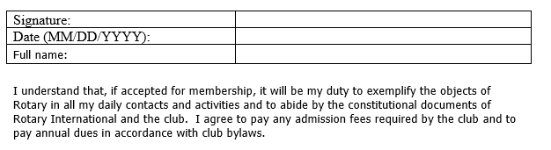
Responsibilities
Initiation fee: (one time only) | $125.00
Annual Rotary International dues: (Jul 1 – June 30) | $150.00
Friday Morning Meeting (Includes Breakfast)/Happy Hour Fellowship Fee | Quarterly $225.00  Per Week $20.00
Proposed new member’s signature:
Date (MM/DD/YYYY)

